# YouTube Video Program:

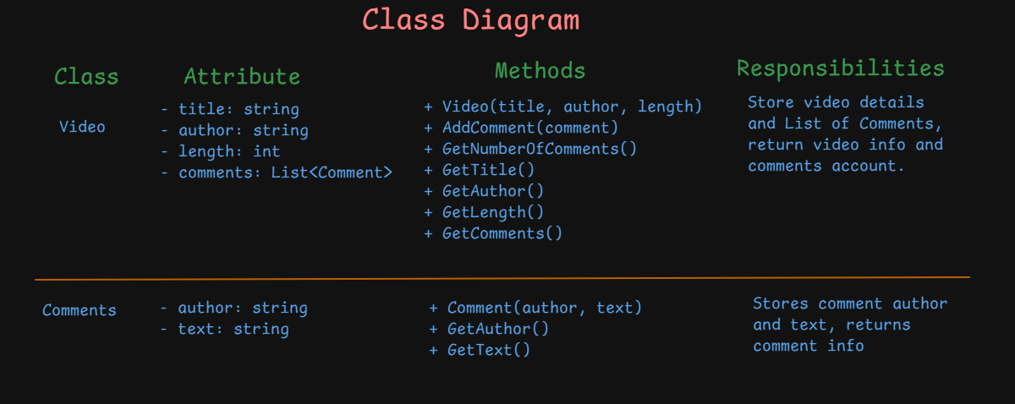

* The program uses two classes: Video and Comment.
* Video stores information about the video and contains a list of Comment objects.
* Each Comment stores the author and the text of a comment.
* This design uses **encapsulation** by keeping data private and exposing access via methods, following good object-oriented programming practices.

# Online Ordering:

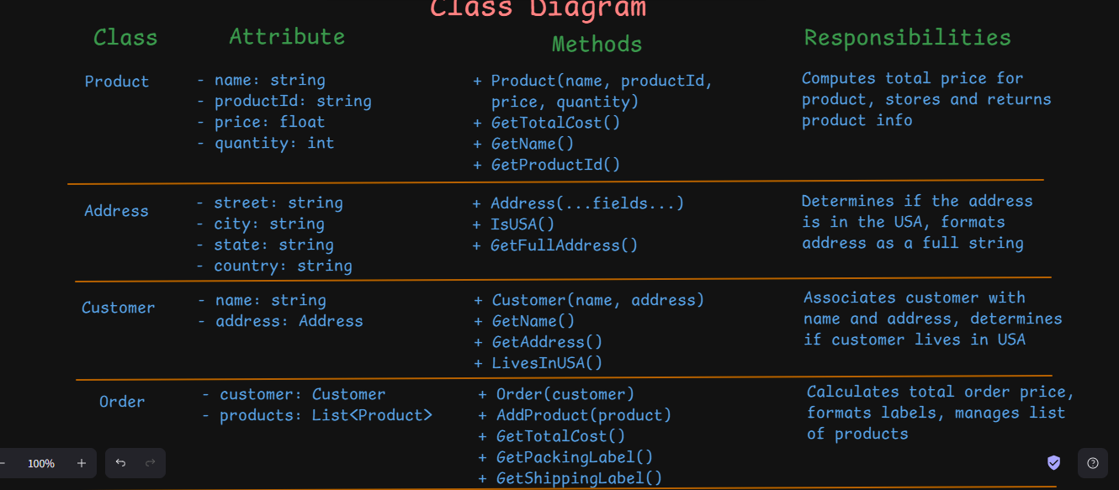

* All fields are **private**, and access is provided only through **methods**.
* Classes expose behaviors like GetTotalCost, LivesInUSA, and label formatting without revealing how data is stored.
* Each class is responsible for its own data and logic, showcasing **clean separation of concerns**.